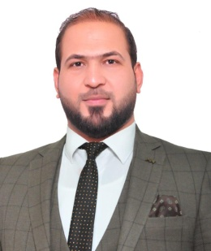

––

***Muhannad Abdul ridha Ali***

***CAREER OBJECTIVES***

**To get in future a responsible challenge position with any good organization, which can provide an opportunity to convert my ability into better performance.**

**And I hope to work in an environmental that gives me the ability to innovate, and develop my abilities, in order to achieve all my goals**

**PERSONAL INFORMATION**



|  |
| --- |
| Birth Date – Place 22,December,1986 – Basra  Nationality Iraqi  Current Address Basra, ALTaameem District  Marital Status marred  Mobile Phone Number 009647709003565  E-Mail Addresses [kacel.saif1986@yahoo.com](mailto:kacel.saif1986@yahoo.com) |

**EDUCATION**

-Mechanical Technique diploma candidate (2010-2011)



Technical institute in Basra

B.S.C in Mechanical engineering candidate (2017-2018)-

University of Basra-Engineering college-Mechanical department

**LANGUAGES SPOKEN**



Arabic ( Native )

English ( Moderate )

**PROJECT GRADUATION**

An experimental study on wear test parameter of pin-Disc contact using regression analysis

**SKILLS**



**COMPUTER SKILLS**

* Auto cad draft man (2D & 3D)
* Good knowledge of computer and MS (office)

**COMMUNICATION SKILLS**

* High presentation skills.
* High skills in social communication via electronic communication networks.
* High portability to do meetings management and participation conferences.
* Good performance in the negotiation and persuasion.

**TRAINING**

Training with BOC for 2 months ( diploma )



Transportation and distribution of electric energy for 2 months ( B.Sc )

**PARTICIPATION CERTIFICATES**



* Non Distractive Test level ii ( VT & RT )
* OSHA & HSE Foundation